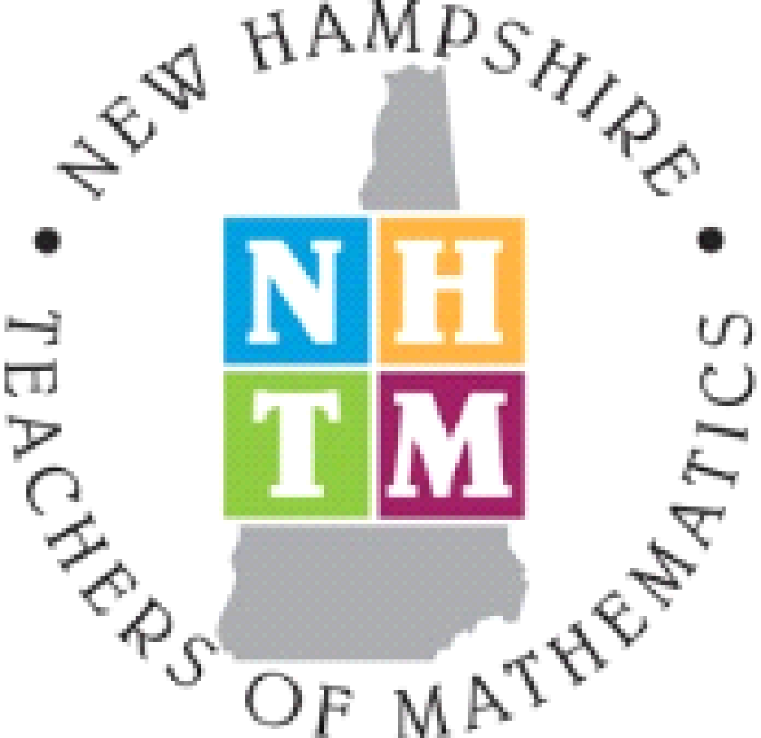

NHTM Board Meeting Minutes
November 14, 2016
Approved 5/23/17

Present: Jeanine King, Katrina Hall, Terry Magnus, Cecile Carlton, Annie Wallace, Stefan Fritz, Rob Lukasiak, Stephanie Wheeler, Elisabeth Johnston, Amy Gregoire, Sharon McCrone, Natalie LaFlamme

1. Annie called the meeting to order at 4:39.

2. Secretary’s Report – (Natalie) In the “Present” section … Elisabeth Johnston’s name is misspelled. Cecile advised that the Treasurer’s actual report not be included in the minutes. It simply needs to be mentioned that the Treasurer made a report to the board. Stephanie motioned to accept the minutes with changes. Cecile seconded it. The motion passed.

3. Treasurer’s Report (Jeanine) - Jeanine presented the report draft with a reminder to check out the tabs at the bottom. The ATMNE conference bills are still being addressed. We will have final details from the ATMNE conference at the next meeting. Amy moved to accept the Treasurer’s report. Terri seconded it. The Treasurer’s report does not need to be accepted or voted upon.

4. Membership Report (Gretchen) - Gretchen will e-mail the report to us sometime this week. We know that we gained 96 new members from the ATMNE conference.

5. Website Update ( Annie for Matt) - A discussion was made about reducing the cost. The cost was raised because of the ATMNE conference contacts. Now that it is over, when should we redo our contacts? Annie will check with Matt about when we can make the changes and reduce our cost. The hope is that we can do it for the January bill.

6. Fall 2016 ATMNE Conference Report (Cecile) - It was a smooth running conference. A total of 387 people registered from DC, FL, NJ, NE, OH, PA, Quebec, and the New England states. NH had 177 participants with MA coming in 2nd then ME, CT, RI, VT. Good numbers, but there were 70 primary presenters and 15 Committee Chairs who received free registration/meals. There were 38 pre-service teachers through Terri and Bev Ferrucci who gave 2 hours of committee time and then were able to participate in the conference for no cost. Thus, there were 123 non-paying participants.
The conference team is still looking at costs - the largest being the Radisson with $6000 a day for the rooms and $12,000 for the technology expenses.. Other expenses like room charges and airfare for speakers are being discussed. Since numbers were less than the 500 hoped for, the expenses were higher per registrant than expected. The committee is hoping to break even in the end.

In the future, we need to advertise the importance of the Balomenos Award winner speaking event. It would have been nice to have more people at that event.

Overall, the PO process and the registration helpers worked out well. We did have a few people not show up and a couple of other glitches, but for the most part it went well.

When people register through the website, they need to register with the e-mail that is on file with NHTM website, otherwise they are listed as “not a current member” and don’t get the discount. We need to advertise this especially before the Spring conference.

Last year, in Maine, the numbers were around 500 with many of the teachers coming from Maine. Many elementary teachers may have chosen to go to Greg Tang who presented a few weeks afterwards. That may have kept the ATMNE elementary teachers down.

In the future, ATMNE should consider Portsmouth or North Conway.

7. Media & Public Relations (Stefan) - Stefan uses Twitter and Facebook from time to time to advertise NHTM news. He is looking for feedback about how he can get the word out … publications, contacts, etc. What has been done in the past? Does he need to build it up from scratch? Can Stefan put something out on the listserve to follow us on Facebook. John Donovan is the contact person for the math listserve. At the last meeting, we talked about having informal meetings to chat and share ideas. Does anyone have any names? Has anyone thought about that? Stefan thinks it is a good idea and we should try it. There are two benefits to this idea … PD and connecting to NHTM. We talked about having wine and cheese at the events so it is social as well. At the meetings we can ask people to share an idea or strategy that they have had success.
We should ask the Regional Coordinators to think about offering this. We need to be careful that we don’t put more on the coordinators than they agreed to take on. They are already trying to get this structure off the ground. How can we incorporate this idea into the regional structure without overwhelming the coordinators? It could be open across regions, too. Sharing events with other coordinators might increase attendance, as well. They can also advertise it.
Annie asked Stefan to follow up with the DOE. There is supposed to be a place where information can be disseminated for organizations like NHTM for educators to see.

8. Elementary Representative Report (Amy) - Nothing new to report.

9. Middle Level Representative Report (Katrina) - Katrina has contacted Stefan to get the information about the Prevost Award out to others.

10. Secondary Level Report (Michelle) - No report.

11. Post-secondary (Sharon) - Nothing new to report.

12. ATMNE Update (Rob) - There was a virtual meeting shortly after the conference on 11/3/16 with new president (Judy Buck). Cecile and Annie were also there. In general, we are all a part of ATMNE. The minutes are available to us on the website.

Highlights are of the meeting: each affiliate will need to submit $3 per member by December 31 with information being sent to Member Chairs soon; the ATMNE Newsletter is coming out on the website soon; Rob is on the Policy and Procedure Committee - it has to do with running the conference; the 2015 Conference in ME went over budget in part due to the cost of the Balomenos Award Reception. It was decided that affiliates will need to pay anything above a 10% overage of the allotted amount for the Balomenos Award Reception.

The next ATMNE conference is Nov 2 & 3, 2017 at the Best Western in Marlborough, MA.

Nominations for the Father B. Award are due soon. Father Stanley Bezuska taught at BC and was a prolific contributor to mathematics education. The regional award in his name is given at the ATMNE conference. The deadline for nominations is March 31, 2017. For more information, you can check out ATMNE’s website under the award tab. Elisabeth will put the details into the newsletter.

For new memberships and membership renewals collected electronically for ATMNE conferences, processing fees proportional to membership fees will be deducted from the amount that the hosting affiliate sends to local affiliates.

12. NCTM Update (Terri) - $500 worth of books were sold at the ATMNE conference. We are not able to get more books on hand to sell since we are a small group. Terri had asked for some additional books (Principles in Action, for example). They sent us two. NCTM could not send us Peg’s book due to publishing constraints.

The annual conference is the 1st week in April in San Antonio. Annie may be going, if her school is not testing then. The regional caucuses and the delegate assembly occur during the conference. Do we have anything to propose or anything that we need as individuals or as an affiliate? Think about it and Terri will ask again at the next meeting. We may want to ask if our regional coordinators have anything to propose or have any questions.
Do many higher ed from the state go? Elisabeth and Sharon have gone in the past. People from UNH have gone.

Perhaps we should invite the regional coordinators to come to one of our NHTM meetings? Annie will look into doing it for our January meeting. That would be a good meeting since we will have info to share about the Spring Dine and Discuss.

13. State Math Contest (Stephen) - Annie reported. Tuesday, March 21 (snow date - Wednesday, March 22). Registration will be going out sometime around Thanksgiving.

14. DoE Updates (Donna) Annie reported that Donna already has a few applicants for the NHPAEMST award which is encouraging.

15. Spring Dine & Discuss and Annual Meeting (Rob and Sharon) - Nice job on the cards advertising the event at the ATMNE conference. Sharon has heard from a lot of people who want to attend (many are not NHTM members). Sharon met with Suzy Gagnon for help. They looked into lots of pricing considerations. They will be sure to keep it under $100 for non-members.
Last year, we had about 100 attendees at the DIne and Discuss. This year, the expectation is about 180 with dinner. That is the maximum for the Holiday Inn. The order of the evening will be
- Appetizers;
- Greg Tang (75 minutes for K-6 audience);
- Dinner and awards;
- Annual members meeting.

A plated dinner gives us more room, but it is more expensive. We need to push to get Elementary teachers there. We want to coordinate Greg’s talk with the summer institute so that people can continue to get more from this. NHTM is willing to promote his summer institute. According to Greg’s website, he has scheduled his institute for August 1-3 in Manchester. Our website needs to be updated for the NHTM Dine and Discuss. Sharon will contact Matty about that. We need to get the information to school administrators so districts can plan. The target audience is elementary teachers, middle school teachers, special educators, 6th grade teachers, and math interventionists. It should be a draw for elementary teachers, but it is also our Annual meeting. So all are encouraged to attend.

A suggestion was made to get some of Greg’s books signed for door prizes.

Let’s hope for good weather since there is no opportunity to have a snow date.

16. Newsletter Update (Elisabeth) - The November newsletter is being worked on. Elisabeth is putting it together now. For the February edition, she tries to get it out by 2/1 which means the next submissions need to be to Elisabeth by 1/17/17.

17. Other Business
a. Regional News (Cecile) Cecile sent an e-mail inquiring what was happening in the regions. Donna Furlong (Southwest region) plans on a book study for Principles to Action. Michelle Morton-Curit (South East) & Steve Latvis ran a PLC on Growth Mindset. There is a book study around Jo Boaler’s Mathematical Mindsets.
Fluency and automaticity is an area of interest. Jessica Jacques (Central) is interested in working with Stephanie about getting this going.

b. Math-Science Collaboration (Science Conference 1April (@Pinkerton) and
summer workshop days @Coe-Brown for elementary teachers (Annie) - Annie has been meeting with NHSTA and went to their board meeting as an invited guest. They are interested in working with us especially with reaching out to elementary teachers. Their Next-Gen science standards were adopted by the state. Their practices mirror our math practices. Annie brought up NH GEMS which many did not know about it. They are interested in presenters for their conference, especially topics that connect math and science. The door is open between our two groups now. They are encouraging our involvement, but it is still an NHSTA conference. Perhaps next year, we will do one together. Cecile suggested putting it on the listserve. Annie has a contact person if we need have any questions.

c. NHSPE Excellence in Teaching Award designee to help rank applicants and
donation request (Annie) - There is an elementary, middle and high school levels engineering award. We have been asked to give a donation, however, we have not given a donation in the past. They would like someone to work with them to help rank the applications that come in. It would take about 3 hours and they will be doing it around January 27. If you would like to do it, let Annie know. We would be open to someone that is a NHTM member, not necessarily a board member.

d. UNH Grant Application Collaboration updates (Annie) - The two grants have been submitted.

e. Nominations Committee (Cecile) - Cecile has someone for every category for elections. She needs candidates for the President-elect position. You can submit names on the website and Cecile will contact them. Cecile is looking to have the bios ready for the ballots to go out in January. The results are announced at the Annual Meeting (Spring Dine and Discuss)
This year’s openings: Treasurer, ATMNE rep, Middle School Rep; Secondary Rep, and President-Elect

f. Updates on Evans, Prevost Award application process (Sharon/Michelle) - Nothing to report yet. Katrina has connected with Stefan about getting the information out. Prevost is new teachers (5 years); Evans is experienced teachers. Katrina is taking the lead on the Prevost and Sharon will do it next year. Amy is taking the lead on the Evans and Michelle will take the lead next year. The information should be put out on the listserve. Katrina (and others) might want to connect with the college people (Keene, UNH, PSU, Rivier, SNHU, St. A’s etc.) that work with the pre-service people because they would know who new teachers are to encourage people to nominate teachers for the Prevost award.

g. Other - No other.

h. Reminder -- Merchandising: Name: NHTM Apparel Store - URL: http://nhtm4all.qbstores.com … great ideas for Christmas, Kwaanza, Hannukah, etc. :-)

The motion to adjourn was made by Terri, seconded by Stephanie. The meeting adjourned at 6:55.

Next Board Meeting Dates: @ PSU, Concord NH (4.30 – 7.00): Thursday 19 January 2017 (Snow date – 26 January)
General Meeting/Spring Dine&Discuss (4.30 – 7.30 ): 16 March 2017, Holiday Inn, Concord, NH
Spring Meeting: Tuesday 23 May 2017 Common Man-Plymouth NH

